Project - High Level Design
on
Multi-Agent Education System

Course Name: Agentic AI

Institution Name: Medicaps University – Datagami Skill Based Course

Student Name(s) & Enrolment Number(s):
Sr no | Student Name | Enrolment Number
1 | Leeni Patidar | EN22CS301554
2 | Mahak Agrawal | EN22CS301563
3 | Kunal Singh Chouhan | EN22CS301540
4 | Krishna Patidar | EN22CS301523

Group Name: 04D5
Project Number: AAI-04
Industry Mentor Name:
University Mentor Name:: Prof. Maya Yadav
Academic Year: 2025-2026

Table of Contents
- Introduction.
  - Scope of the document.
  - Intended Audience
  - System overview.
- System Design.
  - Application Design
  - Process Flow.
  - Information Flow.
  - Components Design
  - Key Design Considerations
  - API Catalogue.
- Data Design.
  - Data Model
  - Data Access Mechanism
  - Data Retention Policies
  - Data Migration
- Interfaces
- State and Session Management
- Caching
- Non-Functional Requirements
  - Security Aspects
  - Performance Aspects
- References

1.Introduction

The Multi-Agent AI Education System (NoteMind AI) is an intelligent study assistant platform designed to generate structured learning materials from a user-provided topic.
The system allows users to:
- Generate Detailed Notes
- Generate Short Notes
- Generate Bullet Points
- Generate Quiz Questions
- Download notes as DOCX
- View previous history
Unlike a normal chatbot, this system uses a multi-agent architecture combined with RAG (Retrieval-Augmented Generation) and a local LLM (Ollama) to ensure structured, high-quality, and context-aware educational content.
The system integrates:
- Multi-Agent orchestration (CrewAI)
- Local LLM (Ollama)
- Vector Database (FAISS)
- Embedding model (SentenceTransformers)
- Web Search (DuckDuckGo)
- Streamlit UI
- Google OAuth Authentication

Scope of the Document
Included in Scope:
- Multi-agent architecture design
- RAG pipeline for education content
- Web search integration
- Local LLM usage (Ollama)
- User authentication
- History management
- DOCX export feature
Out of Scope:
- Training custom LLM models
- Mobile applications
- Real-time collaborative editing
- Cloud deployment architecture
Intended Audience
This documentation is intended for:
Primary Audience:
- Software Developers
- AI/ML Engineers
- System Architects
Secondary Audience:
- Students using the system
- Academic Mentors
- Project Evaluators
Prerequisites:
- Basic understanding of Python
- Knowledge of LLMs
- Understanding of RAG architecture

System Overview
The system follows a Multi-Agent to convert a topic into structured study material.
Core Workflow
- User logs in (Google OAuth / Local Login)
- User enters topic
- User selects note type
- Multi-Agent Orchestration begins:
  - Research Agent gathers web content
  - RAG Agent retrieves relevant stored knowledge
  - Writer Agent generates structured notes
- Notes are displayed in UI
- Notes are saved in user history
- User can download DOCX

2.System Design
Application Type:
Multi-Agent AI Education Assistant
Users:
- End User (Student)
Inputs:
- Topic
- Note Type (Detailed / Short / Bullet)
- Question Type(MCQs / Long Questions /Short Questions)
- Quiz
Output:
- Structured study content

Application Design
Frontend
Technology: Streamlit
Features:
- Login UI
- Topic Input
- Note Type Selector
- Generate Button
- Output Display
- History Section
- Download DOCX

Backend – Python server
Multi-Agent Orchestration (CrewAI)
LLM Layer (Ollama)
RAG Layer (Embedding Model: SentenceTransformers)
Web Search Layer (DuckDuckGo Search)
Authentication Layer (Google OAuth)
Export Layer(python-docx)

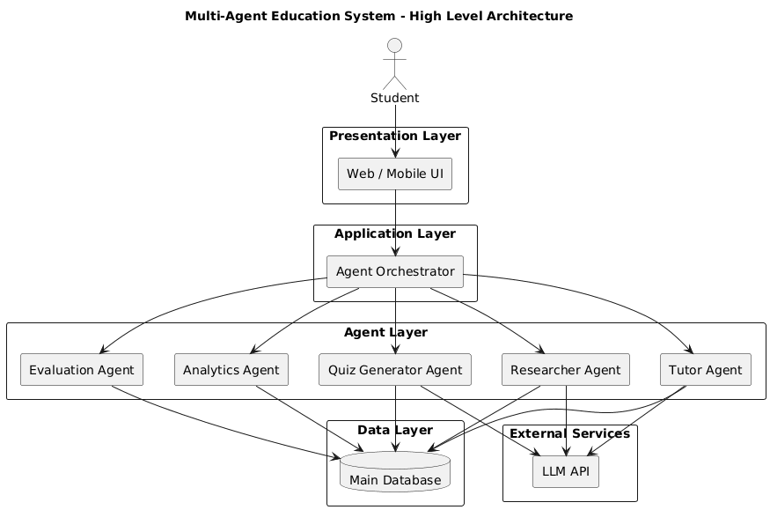
Fig:2.1-Application Design

Process Flow Explanation
The user opens the application and uploads one or more documents, which are converted into text and divided into chunks. These chunks are encoded into vector embeddings and stored in a vector database. When the user enters a query, a semantic search retrieves the most relevant document chunks, and the LLM generates an answer using this retrieved context.
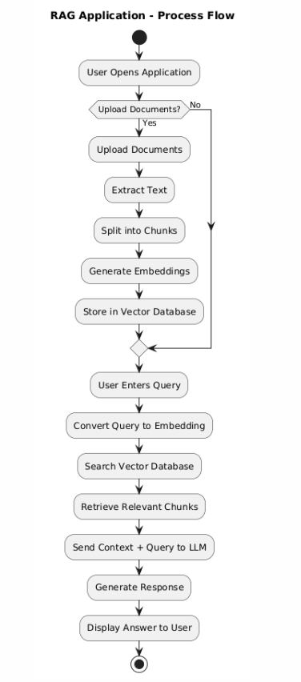
Fig:2.2-Process Flow

Information Flow
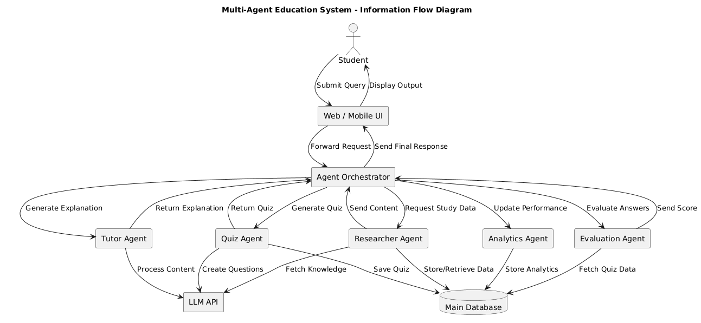

Key Design Considerations :
- Modular agent architecture
- Local LLM for cost efficiency
- Improved accuracy using RAG
- Secure authentication
- Fast vector retrieval using FAISS
- Scalable design
- Clean UI experience
- History persistence

API Catalogue:
If it’s a REST backend (or pseudo-API style):

Method | Endpoint | Description
POST | /generate | Generate notes
POST | /login | User login
GET | /history | Get user history
POST | /export | Export notes

3. Data Design
Data Model
User
→ Topic
→ Multi-Agent Processing
→ Generated Notes
→ Stored in History
Vector Flow:
Topic
→ Embedding
→ FAISS Search
→ Retrieved Context
→ LLM
→ Final Output

4. Interfaces
- Streamlit UI
- Ollama Local Server
- FAISS Vector Store
- Google OAuth Service
- DuckDuckGo Search API

5. State and Session Management
- Streamlit session state used
- User login stored in session
- History stored per user
- Vector index loaded at runtime
.

6. Caching
- FAISS index kept in memory
- Retrieved chunks reused during generation
- Optional caching for repeated queries

7. Non-Functional Requirements

Security

Google OAuth authentication

Password hashing (bcrypt)

Local LLM (no external data sharing)

Performance

FAISS for fast vector search

Local Ollama for low latency

Modular agents for structured processing

8. References
- Streamlit Documentation
- CrewAI Documentation
- Ollama Documentation
- FAISS Documentation
- SentenceTransformers Documentation
- RAG Research Papers

